Coronavirus (Covid19) Guidance
ENGLISH

COVID-19 is a new illness that can affect your lungs and airways. It's caused by a virus called coronavirus.
If you have:
- a high temperature – you feel hot to touch on your chest or back
- a new, continuous cough – this means you've started coughing repeatedly
you should stay at home.

How long to stay at home?
- Anyone with symptoms should stay at home for at least 7 days.
- If you live with other people, they should stay at home for at least 14 days, to avoid spreading the infection outside the home.
- After 14 days, anyone you live with who does not have symptoms can return to their normal routine.
- But, if anyone in your home gets symptoms, they should stay at home for 7 days from the day their symptoms start. Even if it means they're at home for longer than 14 days.
- If you live with someone who is 70 or over, has a long-term condition, is pregnant or has a weakened immune system, try to find somewhere else for them to stay for 14 days.
- If you have to stay at home together, try to keep away from each other as much as possible.

Advice about staying at home

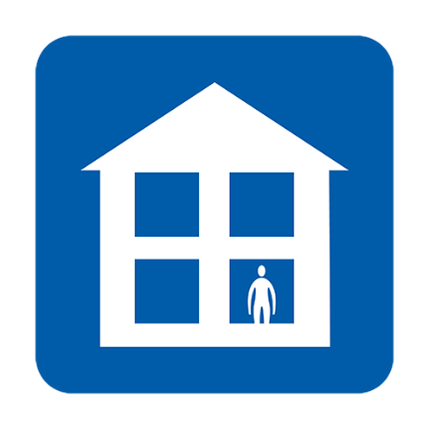  Do not go to work, school, GP surgeries, pharmacy or hospital | 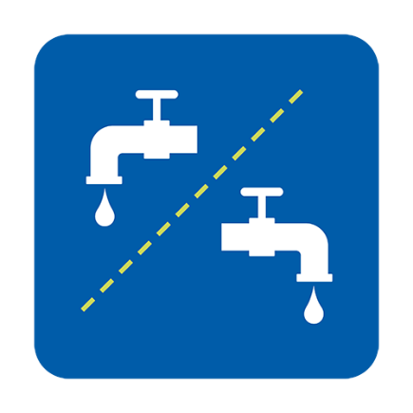  Use separate facilities, or clean between use | 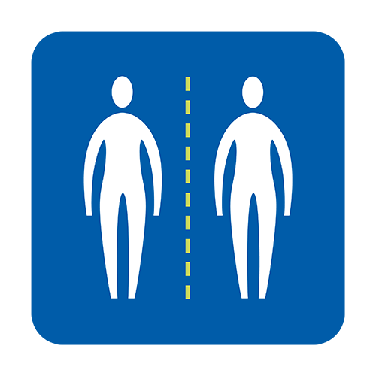  Avoid close contact with other people
Have food & medication delivered to you | 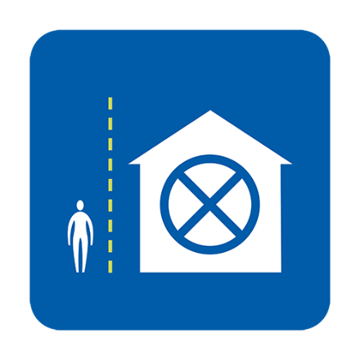  Do not have visitors | 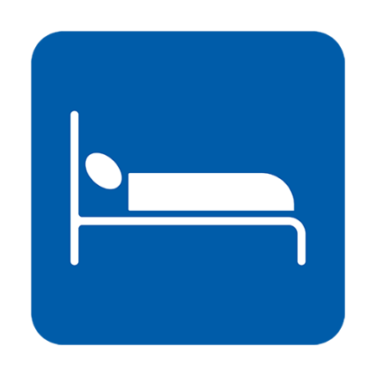  Sleep alone, if possible
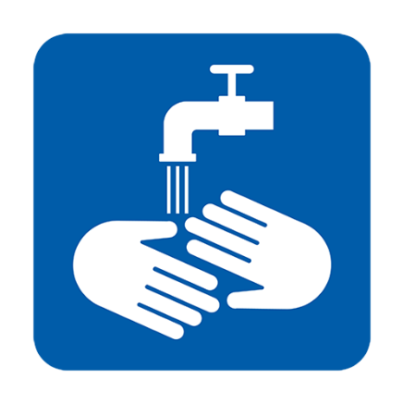  Regularly wash your hands | 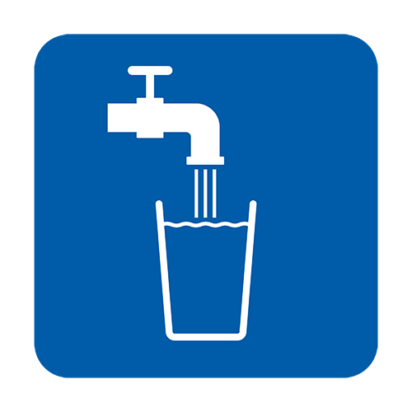  Drink plenty of water | Take paracetamol to help with your symptoms

When should I contact NHS 111?
- you feel so ill that you can't do anything you usually would, such as watch TV, use your phone, read or get out of bed
- you feel you cannot cope with your symptoms at home
- your condition gets worse
- your symptoms do not get better after 7 days

How do I contact NHS 111?
You can use the NHS 111 online coronavirus service to find out what to do next. If you cannot access online services you can call 111 (this is a free number to call). You can ask for an interpreter in your language.

What will happen if I’m worried about my immigration situation?
All NHS services for coronavirus are free for everyone regardless of their immigration status in the UK. This includes coronavirus testing and treatment, even if the result is negative. NHS hospitals have been advised that no immigration checks are required for people receiving testing or treatment for COVID-19.

What can I do to help stop Coronavirus spreading?
- Make sure you wash your hands frequently, using soap and water, for at least 20 seconds
- Follow advice about staying at home

This advice is based on NHS health advice and information and it is an advice for everyone in the UK, regardless of country of origin. For more information:
- NHS Guidance: https://www.nhs.uk/conditions/coronavirus-covid-19/
- WHO guidance: https://www.who.int/news-room/q-a-detail/q-a-coronaviruses

Version 2 [16.03.2020]

